
MARKET INTELLIGENCE REPORT
{{market_name}} Market
Market Outlook
2025 – 2030 Market Outlook
{{market_name}}
CH3OH
{{market_name}}
Technologies
Supplier Landscape
{{company_name}}
Table of content
Chapter 1. Executive Summary 16
1.1. Introduction of {{market_name_upper}} Market 17
1.1.1. {{report_geography}} {{market_name_upper}} Market, 2024 & 2035 17
1.2. {{report_geography}} {{market_name_upper}} Market, 2020 – 2035 (USD MILLION) 18
Chapter 2. Market Introduction – {{market_name_upper}} Market 19
2.1. Market Definition 19
2.2. Scope of the Study 20
2.3. Research Methodology 21
2.4. Key Assumptions 25
Chapter 3. Market Dynamics- {{market_name_upper}} Market 26
3.1. Market Drivers 27
3.2. Market Restraints 28
3.3. Market Opportunities 29
3.4. Market Challenges 30
3.5. Technological Advancements & Innovations 31
Chapter 4. Industry Outlook- {{market_name_upper}} Market 32
4.1. Value Chain Analysis 32
4.2. Regulatory Landscape 34
4.3. ESG (Environmental, Social, Governance) Impact 35
4.4. PESTLE Analysis 36
4.5. Porter’s Five Forces Analysis 37
4.6. Emerging Business Models & Ecosystem Partnerships 38
4.7. Market Attractiveness 39
4.8. {{ch4_custom_section_1_title}} 40
4.9. {{ch4_custom_section_2_title}} 41
4.10. {{ch4_custom_section_3_title}} 42
4.11. {{ch4_custom_section_4_title}} 42
4.11.1. {{ch4_custom_subsection_4_1_title}} 42
Chapter 5. {{market_name_upper}} Market – Type Analysis 43
5.1. {{report_geography}} {{market_name_upper}} Market –Type OVERVIEW 43
5.2. {{report_geography}} {{market_name_upper}} Market Share, by Type, 2024 & 2035 (%) 44
5.3. {{type_segment_1}} 46
5.3.1. {{report_geography}} {{market_name_upper}} Market by {{type_segment_1}}, 2020 – 2035 (usd million) 46
5.4. {{type_segment_2}} 47
5.5. {{type_segment_3}} 47
Chapter 6. {{market_name_upper}} Market – Technology Analysis 48
6.1. {{report_geography}} {{market_name_upper}} Market – Overview 48
6.2. {{report_geography}} {{market_name_upper}} Market Share, by Technology, 2024 & 2035 (%) 49
6.3. {{tech_segment_1}} 51
6.3.1. {{report_geography}} {{market_name_upper}} Market for {{tech_segment_1}}, 2020 – 2035 (USD MILLION) 51
6.4. {{tech_segment_2}} 52
6.5. {{tech_segment_3}} 52
Chapter 7. {{market_name_upper}} Market –Application Analysis 53
7.1. {{report_geography}} {{market_name_upper}} Market –Application Overview 53
7.2. {{report_geography}} {{market_name_upper}} Market Share, by Application, 2024 & 2035 (%) 54
7.3. {{app_segment_1}} 56
7.3.1. {{report_geography}} {{market_name_upper}} Market by {{app_segment_1}}, 2020 - 2035 (USD MILLION) 56
7.4. {{app_segment_2}} 57
7.5. {{app_segment_3}} 57
Chapter 8. {{market_name_upper}} Market –{{seg4_name}} Analysis 58
8.1. {{report_geography}} {{market_name_upper}} Market –{{seg4_name}} Overview 58
8.2. {{report_geography}} {{market_name_upper}} Market Share, by {{seg4_name}}, 2024 & 2035 (%) 59
8.3. {{seg4_sub1}} 61
8.3.1. {{report_geography}} {{market_name_upper}} Market by {{seg4_sub1}}, 2020 - 2035 (USD MILLION) 61
8.4. {{seg4_sub2}} 62
8.5. {{seg4_sub3}} 62
8.6. Sub-{{seg4_name}} 62
Chapter 9. {{market_name_upper}} Market –{{seg5_name}} Analysis 63
9.1. {{report_geography}} {{market_name_upper}} Market –{{seg5_name}} Overview 63
9.2. {{report_geography}} {{market_name_upper}} Market Share, by {{seg5_name}}, 2024 & 2035 (%) 64
9.3. {{seg5_sub1}} 66
9.3.1. {{report_geography}} {{market_name_upper}} Market by {{seg5_sub1}}, 2020 - 2035 (USD MILLION) 66
9.4. {{seg5_sub2}} 67
9.5. {{seg5_sub3}} 67
9.6. Sub-{{seg5_name}} 67
Chapter 10. {{market_name_upper}} Market –{{seg6_name}} Analysis 68
10.1. {{report_geography}} {{market_name_upper}} Market –{{seg6_name}} Overview 68
10.2. {{report_geography}} {{market_name_upper}} Market Share, by {{seg6_name}}, 2024 & 2035 (%) 69
10.3. {{seg6_sub1}} 71
10.3.1. {{report_geography}} {{market_name_upper}} Market by {{seg6_sub1}}, 2020 - 2035 (USD MILLION) 71
10.4. {{seg6_sub2}} 72
10.5. {{seg6_sub3}} 72
10.6. Sub-{{seg6_name}} 72
Chapter 11. {{market_name_upper}} Market – Regional Analysis 73
11.1. {{report_geography}} {{market_name_upper}} Market Regional Overview 73
11.2. {{report_geography}} {{market_name_upper}} Market Share, by Region, 2024 & 2035 (%) 74
11.3. North America 76
11.3.1. North America {{market_name_upper}} Market, 2020 - 2035 (USD MILLION) 76
11.3.2. North America {{market_name_upper}} Market, by Country, 2020 – 2035 (USD MILLION) 77
11.3.3. North America {{market_name_upper}} Market, by Type, 2020 – 2035 (USD MILLION) 77
11.3.4. North America {{market_name_upper}} Market, by Technology, 2020 – 2035 (USD MILLION) 78
11.3.5. North America {{market_name_upper}} Market, by Application, 2020 – 2035 (USD MILLION) 79
11.3.6. North America {{market_name_upper}} Market, by {{seg4_name}}, 2020 – 2035 (USD MILLION) 79
11.3.7. North America {{market_name_upper}} Market, by {{seg5_name}}, 2020 – 2035 (USD MILLION) 80
11.3.8. North America {{market_name_upper}} Market, by {{seg6_name}}, 2020 – 2035 (USD MILLION) 80
11.3.9. U.S. 81
11.3.9.1. U.S. {{market_name_upper}} Market, by Type, 2020 – 2035 (USD MILLION) 82
11.3.9.2. U.S. {{market_name_upper}} Market, by TECHNOLOGY, 2020 – 2035 (USD MILLION) 82
11.3.9.3. U.S. {{market_name_upper}} Market, by Application, 2020 – 2035 (USD MILLION) 83
11.3.9.4. U.S. {{market_name_upper}} Market, by {{seg4_name}}, 2020 – 2035 (USD MILLION) 83
11.3.9.5. U.S. {{market_name_upper}} Market, by {{seg5_name}}, 2020 – 2035 (USD MILLION) 84
11.3.9.6. U.S. {{market_name_upper}} Market, by {{seg6_name}}, 2020 – 2035 (USD MILLION) 84
11.3.10. Canada 85
11.3.10.1. CANADA {{market_name_upper}} Market, by Type, 2020 – 2035 (USD MILLION) 86
11.3.10.2. CANADA {{market_name_upper}} Market, by TECHNOLOGY, 2020 – 2035 (USD MILLION) 86
11.3.10.3. CANADA {{market_name_upper}} Market, by Application, 2020 – 2035 (USD MILLION) 87
11.3.10.4. CANADA {{market_name_upper}} Market, by {{seg4_name}}, 2020 – 2035 (USD MILLION) 87
11.3.10.5. CANADA {{market_name_upper}} Market, by {{seg5_name}}, 2020 – 2035 (USD MILLION) 88
11.3.10.6. CANADA {{market_name_upper}} Market, by {{seg6_name}}, 2020 – 2035 (USD MILLION) 88
11.3.11. Mexico 89
11.3.11.1. MEXICO {{market_name_upper}} Market, by Type, 2020 – 2035 (USD MILLION) 90
11.3.11.2. MEXICO {{market_name_upper}} Market, by TECHNOLOGY, 2020 – 2035 (USD MILLION) 90
11.3.11.3. MEXICO {{market_name_upper}} Market, by Application, 2020 – 2035 (USD MILLION) 91
11.3.11.4. MEXICO {{market_name_upper}} Market, by {{seg4_name}}, 2020 – 2035 (USD MILLION) 91
11.3.11.5. MEXICO {{market_name_upper}} Market, by {{seg5_name}}, 2020 – 2035 (USD MILLION) 92
11.3.11.6. MEXICO {{market_name_upper}} Market, by {{seg6_name}}, 2020 – 2035 (USD MILLION) 92
11.4. Europe 93
11.5. Asia-Pacific 93
11.6. Latin America 93
11.7. Middle East & Africa 93
Chapter 12. {{market_name_upper}} Market – Competitive Landscape 94
12.1. Market Share Analysis (2024) 94
12.2. Strategic Developments 95
12.2.1. AcquisitionsMergers 95
12.2.2. Product Launches 96
12.2.3. Research & Development Activities 96
Chapter 13. Company Profiles 97
13.1. {{co1_name_upper}} 97
13.1.1. Company Overview 97
13.1.2. Product Portfolio 98
13.1.3. {{co1_name_upper}} Sales/Revenue, Net Income,Gross Margin 99
13.1.4. {{co1_name_upper}} Revenue (2023-2025) 100
13.1.5. {{co1_name_upper}} Segmental Revenue (%) (2024) 101
13.1.6. {{co1_name_upper}} Regional Revenue (%) (2025) 102
13.2. {{co2_name}} 103
13.3. {{co3_name}} 103
13.4. {{co4_name}} 103
13.5. {{co5_name}} 103
13.6. Södra 103
13.7. {{co7_name}} 103
13.8. {{co8_name}} 103
13.9. {{co9_name}} 103
13.10. {{co10_name}} 103
Chapter 14. Future Outlook & Forecast- {{market_name_upper}} Market 104
14.1. IntroductionTaxonomy 104
14.2. Demand Forecast 106
14.3. Investment Opportunity 107
14.4. Market Disruptions & Scenario Analysis 108
Chapter 15. Strategic Recommendations – {{market_name_upper}} Market 109
15.1. IntroductionTaxonomy 109
15.2. For Manufacturers 110
15.3. For Investors 111
15.4. For Policy Makers 112
Chapter 16. Appendix 113
16.1. Data Sources 113
16.2. Glossary of Terms 114
16.3. Research Assumptions 115

List of tables
TABLE 1 {{report_geography}} {{market_name_upper}} Market, 2024 & 2035 18
TABLE 2 {{report_geography}} {{market_name_upper}} Market, by Type, 2020 - 2035 (USD MILLION) 46
TABLE 3 {{report_geography}} {{market_name_upper}} Market by {{type_segment_1}}, by Region, 2020 - 2035 48
TABLE 4 {{report_geography}} {{market_name_upper}} Market, by Technology, 2020 - 2035 (USD MILLION) 51
TABLE 5 {{report_geography}} {{market_name_upper}} Market for {{tech_segment_1}}, by Region, 2020 - 2035 (USD MILLION) 53
TABLE 6 {{report_geography}} {{market_name_upper}} Market, by Application, 2020 – 2035 (USD MILLION) 56
TABLE 7 {{report_geography}} {{market_name_upper}} Market by {{app_segment_1}}, by Region, 2020 – 2035 (USD MILLION) 58
TABLE 8 {{report_geography}} {{market_name_upper}} Market, by {{seg4_name}}, 2020 – 2035 (USD MILLION) 61
TABLE 9 {{report_geography}} {{market_name_upper}} Market by {{seg6_sub1}}, by Region, 2020 – 2035 (USD MILLION) 63
TABLE 10 {{report_geography}} {{market_name_upper}} Market, by {{seg5_name}}, 2020 – 2035 (USD MILLION) 66
TABLE 11 {{report_geography}} {{market_name_upper}} Market by {{seg6_sub1}}, by Region, 2020 – 2035 (USD MILLION) 68
TABLE 12 {{report_geography}} {{market_name_upper}} Market, by {{seg6_name}}, 2020 – 2035 (USD MILLION) 71
TABLE 13 {{report_geography}} {{market_name_upper}} Market by {{seg6_sub1}}, by Region, 2020 – 2035 (USD MILLION) 73
TABLE 14 {{report_geography}} {{market_name_upper}} Market, by Region, 2020 – 2035 (USD MILLION) 76
TABLE 15 North America {{market_name_upper}} Market, by Country, 2020 – 2035 (USD MILLION) 78
TABLE 16 North America {{market_name_upper}} Market, by Type, 2020 – 2035 (USD MILLION) 78
TABLE 17 North America {{market_name_upper}} Market, by Technology, 2020 – 2035 (USD MILLION) 79
TABLE 18 North America {{market_name_upper}} Market, by Application, 2020 – 2035 (USD MILLION) 80
TABLE 19 North America {{market_name_upper}} Market, by {{seg4_name}}, 2020 – 2035 (USD MILLION) 80
TABLE 20 North America {{market_name_upper}} Market, by {{seg5_name}}, 2020 – 2035 (USD MILLION) 81
TABLE 21 North America {{market_name_upper}} Market, by {{seg6_name}}, 2020 – 2035 (USD MILLION) 81
TABLE 22 U.S. {{market_name_upper}} Market, by Type, 2020 – 2035 (USD MILLION) 83
TABLE 23 U.S. {{market_name_upper}} Market, by TECHNOLOGY, 2020 – 2035 (USD MILLION) 83
TABLE 24 U.S. {{market_name_upper}} Market, by Application, 2020 – 2035 (USD MILLION) 84
TABLE 25 U.S. {{market_name_upper}} Market, by {{seg4_name}}, 2020 – 2035 (USD MILLION) 84
TABLE 26 U.S. {{market_name_upper}} Market, by {{seg5_name}}, 2020 – 2035 (USD MILLION) 85
TABLE 27 U.S. {{market_name_upper}} Market, by {{seg6_name}}, 2020 – 2035 (USD MILLION) 85
TABLE 28 CANADA {{market_name_upper}} Market, by Type, 2020 – 2035 (USD MILLION) 87
TABLE 29 CANADA {{market_name_upper}} Market, by TECHNOLOGY, 2020 – 2035 (USD MILLION) 87
TABLE 30 CANADA {{market_name_upper}} Market, by Application, 2020 – 2035 (USD MILLION) 88
TABLE 31 CANADA {{market_name_upper}} Market, by {{seg4_name}}, 2020 – 2035 (USD MILLION) 88
TABLE 32 CANADA {{market_name_upper}} Market, by {{seg5_name}}, 2020 – 2035 (USD MILLION) 89
TABLE 33 CANADA {{market_name_upper}} Market, by {{seg6_name}}, 2020 – 2035 (USD MILLION) 89
TABLE 34 MEXICO {{market_name_upper}} Market, by Type, 2020 – 2035 (USD MILLION) 91
TABLE 35 MEXICO {{market_name_upper}} Market, by TECHNOLOGY, 2020 – 2035 (USD MILLION) 91
TABLE 36 MEXICO {{market_name_upper}} Market, by Application, 2020 – 2035 (USD MILLION) 92
TABLE 37 MEXICO {{market_name_upper}} Market, by {{seg4_name}}, 2020 – 2035 (USD MILLION) 92
TABLE 38 MEXICO {{market_name_upper}} Market, by {{seg5_name}}, 2020 – 2035 (USD MILLION) 93
TABLE 39 MEXICO {{market_name_upper}} Market, by {{seg6_name}}, 2020 – 2035 (USD MILLION) 93
TABLE 40 AcquisitionsMergers 96
TABLE 41 Company snapshot 99

List of Figures
Figure 01 {{report_geography}} {{market_name_upper}} Market, 2020 – 2035 (USD MILLION) 19
Figure 02 Market Dynamics 27
Figure 03 Technological Advancements & Innovations 32
Figure 04 Value Chain Analysis 33
Figure 05 {{report_geography}} {{market_name_upper}} Market Share, by Type, 2024 & 2035 (%) 45
Figure 06 {{report_geography}} {{market_name_upper}} Market by {{type_segment_1}}, 2020 - 2035 47
Figure 07 {{report_geography}} {{market_name_upper}} Market Share, by Technology, 2024 & 2035 50
Figure 08 {{report_geography}} {{market_name_upper}} Market for {{tech_segment_1}}, 2020 - 2035 (USD MILLION) 52
Figure 09 {{report_geography}} {{market_name_upper}} Market Share, by Application, 2024 & 2035 (%) 55
Figure 10 {{report_geography}} {{market_name_upper}} Market by {{app_segment_1}}, 2020 – 2035 (USD MILLION) 57
Figure 11 {{report_geography}} {{market_name_upper}} Market Share, by {{seg4_name}}, 2024 & 2035 (%) 60
Figure 12 {{report_geography}} {{market_name_upper}} Market by {{seg6_sub1}}, 2020 – 2035 (USD MILLION) 62
Figure 13 {{report_geography}} {{market_name_upper}} Market Share, by {{seg5_name}}, 2024 & 2035 (%) 65
Figure 14 {{report_geography}} {{market_name_upper}} Market by {{seg6_sub1}}, 2020 – 2035 (USD MILLION) 67
Figure 15 {{report_geography}} {{market_name_upper}} Market Share, by {{seg6_name}}, 2024 & 2035 (%) 70
Figure 16 {{report_geography}} {{market_name_upper}} Market by {{seg6_sub1}}, 2020 – 2035 (USD MILLION) 72
Figure 17 {{report_geography}} {{market_name_upper}} Market Share, by Region, 2024 & 2035 (%) 75
Figure 18 North America {{market_name_upper}} Market, 2020 - 2035 (USD MILLION) 77
Figure 19 U.S. {{market_name_upper}} Market, 2020 – 2035 (USD MILLION) 82
Figure 20 Canada {{market_name_upper}} Market, 2020 – 2035 (USD MILLION) 86
Figure 21 Mexico {{market_name_upper}} Market, 2020 – 2035 (USD MILLION) 90
Figure 22 Market Share Analysis (2024) 95
Figure 23 {{co1_name_upper}} REVENUE (2023-2025) 101
Figure 24 {{co1_name_upper}} SEGMENTAL Revenue (%) (2024) 102
Figure 25 {{co1_name_upper}} Regional Revenue (%) (2025) 103

- Executive Summary
{{market_name}} is a dynamic and evolving market driven by diverse product offerings, technological innovation, and shifting consumer preferences. The market encompasses a wide range of {{type_segment_1}}, {{type_segment_2}}, and {{type_segment_3}} solutions designed to meet the needs of various end-user industries. {{app_segment_1}}, {{app_segment_2}}, and {{app_segment_3}} represent key application areas driving demand across global markets.
Uses & Applications:
- {{app_segment_1}}: This segment represents a primary application area for {{market_name}}, driven by sustained demand, ongoing product innovation,expanding end-user adoption across multiple geographic markets.
- {{app_segment_4}}: Used to produce "green" plastics, resins,adhesives, enabling a sustainable supply chain for consumer goods.
- {{app_segment_3}}: This application segment has demonstrated significant growth potential, supported by technological advancements, favorable market dynamics,increasing investment from key industry participants.
- {{app_segment_2}}: This segment offers substantial opportunities for market participants, driven by evolving consumer preferences, regulatory support,expanding use cases across diverse end-user industries.

  - Introduction of {{market_name_upper}} Market
    - {{report_geography}} {{market_name_upper}} Market, 2024 & 2035
- {{report_geography}} {{market_name_upper}} Market, 2024 & 2035
Parameter | {{base_year}} | {{forecast_end_year}}
{{report_geography}} {{market_name}} Market Value (USD Million) | XX | XX
CAGR % (2025-2035) | XX%
Largest Market Segment, by Type (USD Million) | XX Segment: XX | XX Segment: XX
Largest Market Segment, by Technology (USD Million) | XX Segment: XX | XX Segment: XX
Largest Market Segment, by Application (USD Million) | XX Segment: XX | XX Segment: XX
Key Growth Market Segment, by Region CAGR % (2025-2035) | XX Segment – XX%
Source: Primary Interviews, Surveys, Secondary Sources, Web-Based & Paid External Databases, 2025

  - {{report_geography}} {{market_name_upper}} Market, 2020 – 2035 (USD MILLION)
- {{report_geography}} {{market_name_upper}} Market, 2020 – 2035 (USD MILLION)
Source: Primary Interviews, Surveys, Secondary Sources, Web-Based & Paid External Databases, 2025

- Market Introduction – {{market_name_upper}} Market
  - Market Definition
Key trends shaping the {{market_name}} market include technological advancements, shifting consumer preferences toward innovative products, and expanding applications across diverse industry verticals. Market participants are increasingly focusing on product innovation, strategic partnerships, and geographic expansion to capture emerging growth opportunities.

  - Scope of the Study
This report segments the global {{market_name}} Market as follows:
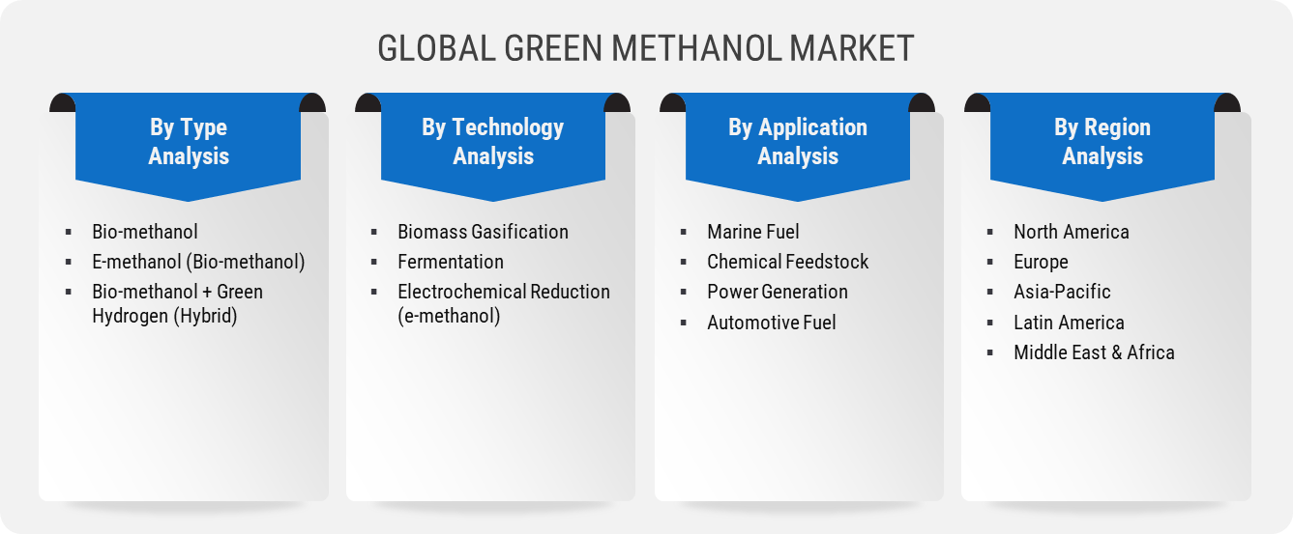
GLOBAL {{MARKET_NAME_UPPER}} MARKET
- {{type_segment_1}}
- {{type_segment_2}}
- {{type_segment_3}}

By Type
Analysis
By Application Analysis
By Technology Analysis
By Region
Analysis
- {{app_segment_1}}
- {{app_segment_2}}
- {{app_segment_3}}
- {{app_segment_4}}

- {{tech_segment_1}}
- {{tech_segment_2}}
- {{tech_segment_3}}

- North America
- Europe
- Asia-Pacific
- Latin America
- Middle East & Africa
Source: 2025

  - Research Methodology
Source: 2025
We adopts a thoroughiterative research methodology designed to minimize deviations and deliver the most precise estimates and forecasts. The company applies both bottom-up and top-down approaches to segment the market and quantify key metrics accurately. A consistent feature across all our research reports is data triangulation, which examines the market from three distinct perspectives to enhance reliability. Core Industry of our research methodology include:

Preliminary Data Mining
The research process starts with the broad collection of raw market data sourced from validatedcredible channels. This data undergoes continuous filtration to ensure only verified and relevant information is retained. In addition to leveraging proprietary databases and internal report archives, data is sourced from trusted, subscription-based Types.
To develop a holistic view of the market, the entire value chain is analyzed—gathering insights from TECHNOLOGYs suppliers, intermediaries, distributors,Industry. Technical developments and industry challenges are captured through targeted surveys, expert conferences, and respected trade journals. Intellectual property research, including white space and freedom-to-operate analysis, adds depth to the Trial Phase evaluation. Key market drivers, restraints, pricing trends, and competitive dynamics are also compiled and validated against published data to ensure consistency and accuracy.

Statistical Model
Forecastsmarket estimates are developed using tailored simulation models crafted for each specific study. Key inputs—including market drivers, pricing trends, product, and the evolving technological landscape—are analyzed concurrently using statistical methods such as regression analysis, time series forecasting, and correlation modeling.
Short-term forecasts rely heavily on econometric models, while long-term projections incorporate factors such as technological developments, regulatory shifts, macroeconomic trends,strategic business insights. A bottom-up estimation approach is applied, starting at the regional level and aggregating to form global estimates, ensuring both accuracy and a comprehensive understanding of market dynamics:
Key parameters considered for forecasting include:
- Key market driversrestraints are identified, along with an assessment of their projected impact over time.
- Trends in TECHNOLOGY availabilitypricing are closely monitored to understand their influence on the market.
- The regulatory landscape is evaluated, including current frameworksexpected policy shifts.
- Existing capacity is analyzed, with forecasts extending to planned expansions through 2033.
A weighted average analysis is applied to assign appropriate significance to each factor, ensuring a balancedcomprehensive projection of market growth.
Primary Validation
Primary validation marks the final phase of our market estimationforecasting process. At this stage, in-depth interviews are conducted—both in person and via phone—with key stakeholders to verify the accuracy of collected data and the assumptions driving our analysis.
Interviewees are carefully selected from leading organizations across the industry value chain, including product suppliers, Application developers, domain experts,others. This diverse representation ensures a balanced and objective view of the market.
To ensure comprehensive global coverage, interviews are conducted across multiple regions, with language differences managed through local staff or professional interpreters. These conversations not only validate our findings but also provide valuable insights into current trends, evolving business conditions,future developments, significantly enriching the quality of our analysis.
All projections are rigorously validated through direct engagement with Key Industry Participants (KIPs), typically comprising:
- Major industry players
- Product suppliers
- Distributorslogistics providers
- ProductApplication buyers
The Key Objectives of Primary Research are as Follows:
- Verify the accuracy, credibility,relevance of the gathered data
- Gain a clear understanding of current market dynamicscollect expert insights on anticipated future trends

  - Key Assumptions

- Market Dynamics- {{market_name_upper}} Market
- Market Dynamics
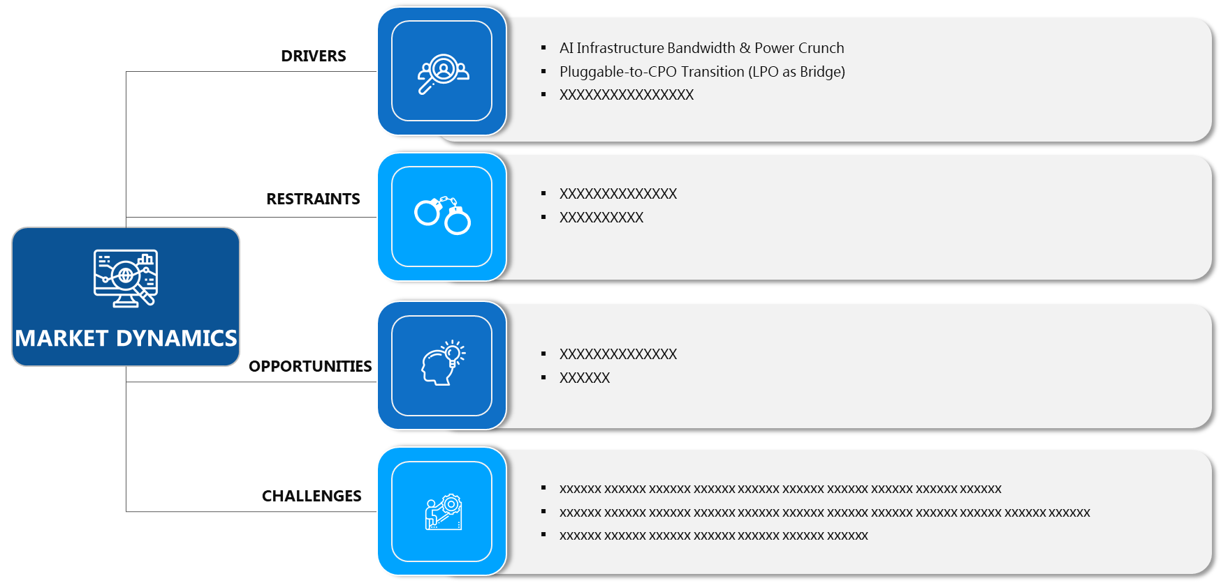
Source: 2025
  - Market Drivers
Increasing Demand Across Key End-Use Industries
The {{market_name}} market is experiencing robust growth driven by rising demand from established and emerging end-use industries. Key sectors such as {{app_segment_1}}, {{app_segment_2}}, and {{app_segment_3}} are increasingly adopting {{market_name}}-based solutions to meet their operational and performance requirements. Government regulations, sustainability initiatives, and technological advancements are creating a favorable environment for market expansion across multiple regions.
Major industry participants are investing in production capacity expansion, research and development initiatives, and strategic collaborations to capitalize on growing market demand. This investment creates a positive feedback loop that drives further innovation and market development across the value chain. End-user industries are increasingly prioritizing {{market_name}} solutions that offer improved performance, cost-effectiveness, and alignment with evolving regulatory standards.

Technological Advancements and Product Innovation
Continuous technological advancements are expanding the potential applications and improving the performance characteristics of {{market_name}} products. Innovations in manufacturing processes, material science, and product design are enabling new use cases and enhancing the value proposition for end-users. Companies are investing in research and development to create next-generation solutions that address evolving market demands.
Research and development investments by both established companies and emerging startups are accelerating the pace of innovation in the {{market_name}} market. These advancements are expected to unlock new market segments, improve production efficiency, and drive further growth over the forecast period. Strategic partnerships between technology providers and end-users are facilitating the commercialization of innovative solutions.

  - Market Restraints
Raw Material Price Volatility and Supply Chain Constraints
The {{market_name}} market faces challenges related to raw material price fluctuations, supply chain disruptions, and production cost pressures. These factors can impact profit margins for manufacturers and influence pricing strategies across the value chain. Market participants are implementing cost optimization measures and diversifying their supplier base to mitigate these risks.
{{type_segment_1}} providers are addressing these challenges through vertical integration, strategic sourcing arrangements, and operational efficiency improvements. Companies across the value chain are focusing on optimizing their supply chains and implementing cost reduction initiatives to maintain competitiveness in the evolving {{market_name}} marketplace.

  - Market Opportunities



  - Market Challenges

  - Technological Advancements & Innovations
- Technological Advancements & Innovations
Source: 2025
- Industry Outlook- {{market_name_upper}} Market
  - Value Chain Analysis
- Value Chain Analysis
Source: 2025
Value Chain Analysis is a strategic framework used to examine the internal activities of a business or industry to understand how value is createdwhere competitive advantage can be gained. The objective is to analyze each step involved in the marketing, and delivery of a device or service, from initial sourcing to after-sales support, in order to identify opportunities for cost reduction, process improvement, or value enhancement.
The value chain is typically divided into two categories: primary activitiessupport activities. Primary activities are directly involved in the creation and delivery of a product or service. These include inbound logistics, which encompasses the receiving and storage; operations, which refers to the transformation of inputs into final product; outbound logistics, which involves the distribution of finished goods; marketing and sales, which focus on customer engagement and revenue generation; and service, which includes post-sale support such as maintenance and customer care.
Support activities, on the other hand, provide the necessary infrastructureinputs that allow the primary activities to function efficiently. These include firm here infrastructure such as finance, planning, and legal; human resource management, which ensures the recruitment and development of skilled personnel; product development, which drives innovation and process improvement; and procurement, which involves acquiring the resources and inputs required for device.
Conducting a value chain analysis enables organizations to identify specific activities where value is added or lost. This insight supports strategic decisions such as outsourcing non-core functions, investing in product to streamline operations, or reengineering processes to better meet customer needs. Furthermore, by benchmarking against competitors, firms can assess where they hold cost or differentiation advantages within the value chain.
Ultimately, value chain analysis is a powerful tool for uncovering internal strengthsweaknesses, aligning operations with strategic goals, and enhancing overall organizational performance. It plays a crucial role in shaping competitive strategy by focusing on activities that contribute most to customer value and business success.

  - Regulatory Landscape

Source: 2025

  - ESG (Environmental, Social, Governance) Impact
Source: 2025

  - PESTLE Analysis
Source: 2025

  - Porter’s Five Forces Analysis
Source: 2025
  - Emerging Business Models & Ecosystem Partnerships

  - Market Attractiveness
ment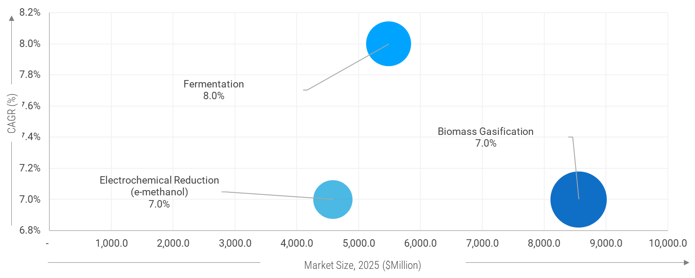
CAGR (%)
Market Size, 2025 ($Million)
Source: 2025
Note: The Above figures are for illustrative purposessimilar attractiveness will be covered for rest of segmentation.

  - {{ch4_custom_section_1_title}}

  - {{ch4_custom_section_2_title}}

  - {{ch4_custom_section_3_title}}
  - {{ch4_custom_section_4_title}}
    - {{ch4_custom_subsection_4_1_title}}

- {{market_name_upper}} Market – Type Analysis
  - {{report_geography}} {{market_name_upper}} Market –Type OVERVIEW

  - {{report_geography}} {{market_name_upper}} Market Share, by Type, 2024 & 2035 (%)
- {{report_geography}} {{market_name_upper}} Market Share, by Type, 2024 & 2035 (%)
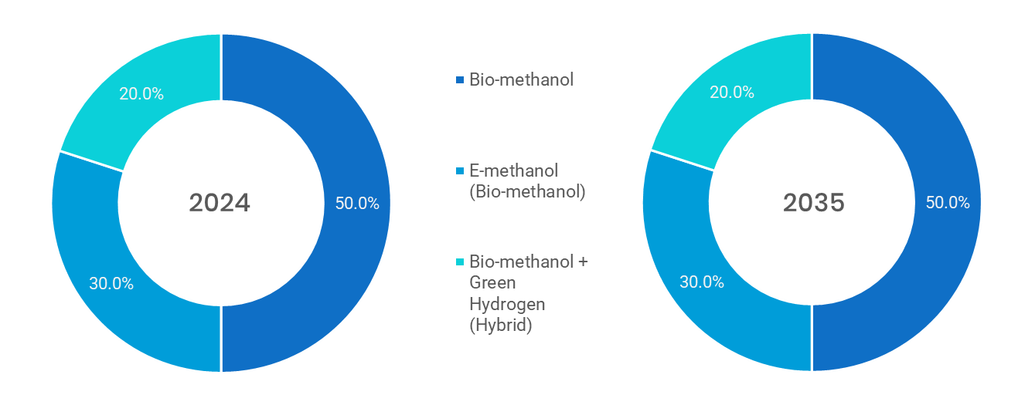
Source: Primary Interviews, Surveys, Secondary Sources, Web-Based & Paid External Databases, 2025
Note: Charts & Figures only for Illustration purposes
- {{report_geography}} {{market_name_upper}} Market, by Type, 2020 - 2035 (USD MILLION)
By Type | {{history_start_year}} | 2021 | 2022 | 2023 | {{base_year}} | {{forecast_start_year}} | 2026 | 2027 | 2028 | 2029 | 2030 | 2031 | 2032 | 2033 | 2034 | 20235 | CAGR%  (2025-2035)
{{type_segment_1}} | XX | XX | XX | XX | XX | XX | XX | XX | XX | XX | XX | XX | XX | XX | XX | XX | XX
{{type_segment_2}} | XX | XX | XX | XX | XX | XX | XX | XX | XX | XX | XX | XX | XX | XX | XX | XX | XX
{{type_segment_3}} | XX | XX | XX | XX | XX | XX | XX | XX | XX | XX | XX | XX | XX | XX | XX | XX | XX
Total | XX | XX | XX | XX | XX | XX | XX | XX | XX | XX | XX | XX | XX | XX | XX | XX | XX
Source: Primary Interviews, Surveys, Secondary Sources, Web-Based & Paid External Databases, 2025

  - {{type_segment_1}}
    - {{report_geography}} {{market_name_upper}} Market by {{type_segment_1}}, 2020 – 2035 (usd million)
- {{report_geography}} {{market_name_upper}} Market by {{type_segment_1}}, 2020 - 2035
Source: Primary Interviews, Surveys, Secondary Sources, Web-Based & Paid External Databases, 2025

- {{report_geography}} {{market_name_upper}} Market by {{type_segment_1}}, by Region, 2020 - 2035
By Region | {{history_start_year}} | 2021 | 2022 | 2023 | {{base_year}} | {{forecast_start_year}} | 2026 | 2027 | 2028 | 2029 | 2030 | 2031 | 2032 | 2033 | 2034 | {{forecast_end_year}} | CAGR%  (2025-2035)
North America | XX | XX | XX | XX | XX | XX | XX | XX | XX | XX | XX | XX | XX | XX | XX | XX | XX
Europe | XX | XX | XX | XX | XX | XX | XX | XX | XX | XX | XX | XX | XX | XX | XX | XX | XX
Asia-Pacific | XX | XX | XX | XX | XX | XX | XX | XX | XX | XX | XX | XX | XX | XX | XX | XX | XX
Latin America | XX | XX | XX | XX | XX | XX | XX | XX | XX | XX | XX | XX | XX | XX | XX | XX | XX
Middle East & Africa | XX | XX | XX | XX | XX | XX | XX | XX | XX | XX | XX | XX | XX | XX | XX | XX | XX
Total | XX | XX | XX | XX | XX | XX | XX | XX | XX | XX | XX | XX | XX | XX | XX | XX | XX
Source: Primary Interviews, Surveys, Secondary Sources, Web-Based & Paid External Databases, 2025

*The above similar information will be cover for below segment as well.
  - {{type_segment_2}}
  - {{type_segment_3}}
- {{market_name_upper}} Market – Technology Analysis
  - {{report_geography}} {{market_name_upper}} Market – Overview

  - {{report_geography}} {{market_name_upper}} Market Share, by Technology, 2024 & 2035 (%)
- {{report_geography}} {{market_name_upper}} Market Share, by Technology, 2024 & 2035
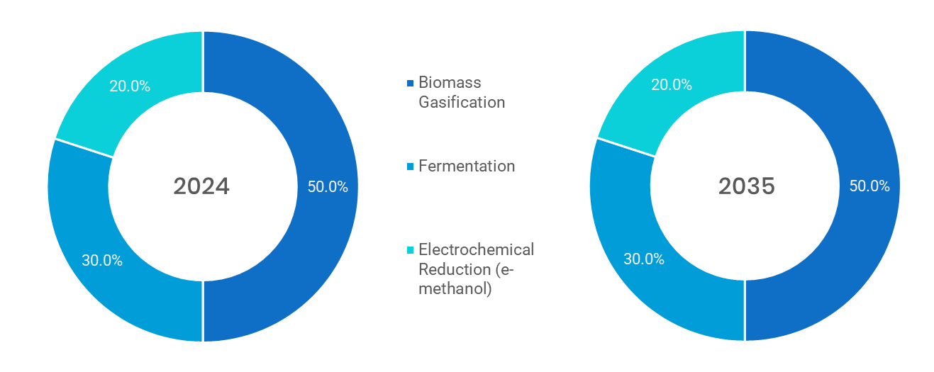
Source: Primary Interviews, Surveys, Secondary Sources, Web-Based & Paid External Databases, 2025
Note: Charts & Figures are only for Illustration purposes

- {{report_geography}} {{market_name_upper}} Market, by Technology, 2020 - 2035 (USD MILLION)
By TECHNOLOGY | {{history_start_year}} | 2021 | 2022 | 2023 | {{base_year}} | {{forecast_start_year}} | 2026 | 2027 | 2028 | 2029 | 2030 | 2031 | 2032 | 2033 | 2034 | {{forecast_end_year}} | CAGR%  (2025-2035)
{{tech_segment_1}} | XX | XX | XX | XX | XX | XX | XX | XX | XX | XX | XX | XX | XX | XX | XX | XX | XX
{{tech_segment_2}} | XX | XX | XX | XX | XX | XX | XX | XX | XX | XX | XX | XX | XX | XX | XX | XX | XX
{{tech_segment_3}} | XX | XX | XX | XX | XX | XX | XX | XX | XX | XX | XX | XX | XX | XX | XX | XX | XX
Total | XX | XX | XX | XX | XX | XX | XX | XX | XX | XX | XX | XX | XX | XX | XX | XX | XX
Source: Primary Interviews, Surveys, Secondary Sources, Web-Based & Paid External Databases, 2025

  - {{tech_segment_1}}
    - {{report_geography}} {{market_name_upper}} Market for {{tech_segment_1}}, 2020 – 2035 (USD MILLION)
- {{report_geography}} {{market_name_upper}} Market for {{tech_segment_1}}, 2020 - 2035 (USD MILLION)
Source: Primary Interviews, Surveys, Secondary Sources, Web-Based & Paid External Databases, 2025

- {{report_geography}} {{market_name_upper}} Market for {{tech_segment_1}}, by Region, 2020 - 2035 (USD MILLION)
By Region | {{history_start_year}} | 2021 | 2022 | 2023 | {{base_year}} | {{forecast_start_year}} | 2026 | 2027 | 2028 | 2029 | 2030 | 2031 | 2032 | 2033 | 2034 | {{forecast_end_year}} | CAGR%  (2025-2035)
North America | XX | XX | XX | XX | XX | XX | XX | XX | XX | XX | XX | XX | XX | XX | XX | XX | XX
Europe | XX | XX | XX | XX | XX | XX | XX | XX | XX | XX | XX | XX | XX | XX | XX | XX | XX
Asia-Pacific | XX | XX | XX | XX | XX | XX | XX | XX | XX | XX | XX | XX | XX | XX | XX | XX | XX
Latin America | XX | XX | XX | XX | XX | XX | XX | XX | XX | XX | XX | XX | XX | XX | XX | XX | XX
Middle East & Africa | XX | XX | XX | XX | XX | XX | XX | XX | XX | XX | XX | XX | XX | XX | XX | XX | XX
Total | XX | XX | XX | XX | XX | XX | XX | XX | XX | XX | XX | XX | XX | XX | XX | XX | XX
Source: Primary Interviews, Surveys, Secondary Sources, Web-Based & Paid External Databases, 2025

*The above similar information will be cover for below segment.
  - {{tech_segment_2}}
  - {{tech_segment_3}}
- {{market_name_upper}} Market –Application Analysis
  - {{report_geography}} {{market_name_upper}} Market –Application Overview

  - {{report_geography}} {{market_name_upper}} Market Share, by Application, 2024 & 2035 (%)
- {{report_geography}} {{market_name_upper}} Market Share, by Application, 2024 & 2035 (%)
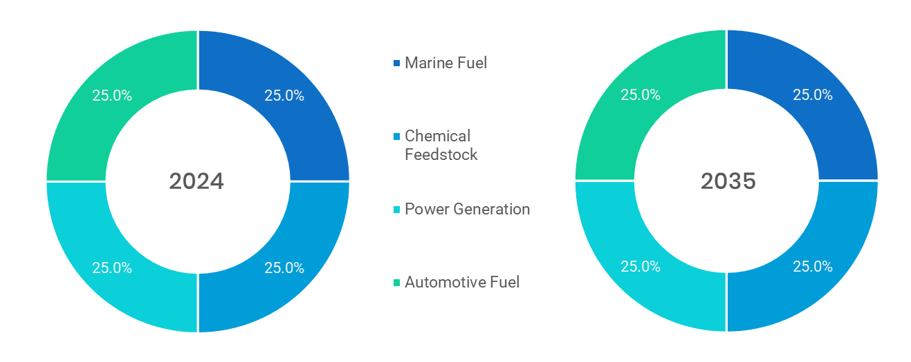
Source: Primary Interviews, Surveys, Secondary Sources, Web-Based & Paid External Databases, 2025
Note: Charts & Figures only for Illustration purposes
- {{report_geography}} {{market_name_upper}} Market, by Application, 2020 – 2035 (USD MILLION)
By Application | {{history_start_year}} | 2021 | 2022 | 2023 | {{base_year}} | {{forecast_start_year}} | 2026 | 2027 | 2028 | 2029 | 2030 | 2031 | 2032 | 2033 | 2034 | {{forecast_end_year}} | CAGR%  (2025-2035)
{{app_segment_1}} | XX | XX | XX | XX | XX | XX | XX | XX | XX | XX | XX | XX | XX | XX | XX | XX | XX
{{app_segment_4}} | XX | XX | XX | XX | XX | XX | XX | XX | XX | XX | XX | XX | XX | XX | XX | XX | XX
{{app_segment_2}} | XX | XX | XX | XX | XX | XX | XX | XX | XX | XX | XX | XX | XX | XX | XX | XX | XX
{{app_segment_3}} | XX | XX | XX | XX | XX | XX | XX | XX | XX | XX | XX | XX | XX | XX | XX | XX | XX
Total | XX | XX | XX | XX | XX | XX | XX | XX | XX | XX | XX | XX | XX | XX | XX | XX | XX
Source: Primary Interviews, Surveys, Secondary Sources, Web-Based & Paid External Databases, 2025

  - {{app_segment_1}}
    - {{report_geography}} {{market_name_upper}} Market by {{app_segment_1}}, 2020 - 2035 (USD MILLION)
- {{report_geography}} {{market_name_upper}} Market by {{app_segment_1}}, 2020 – 2035 (USD MILLION)
Source: Primary Interviews, Surveys, Secondary Sources, Web-Based & Paid External Databases, 2025

- {{report_geography}} {{market_name_upper}} Market by {{app_segment_1}}, by Region, 2020 – 2035 (USD MILLION)
By Region | {{history_start_year}} | 2021 | 2022 | 2023 | {{base_year}} | {{forecast_start_year}} | 2026 | 2027 | 2028 | 2029 | 2030 | 2031 | 2032 | 2033 | 2034 | {{forecast_end_year}} | CAGR%  (2025-2035)
North America | XX | XX | XX | XX | XX | XX | XX | XX | XX | XX | XX | XX | XX | XX | XX | XX | XX
Europe | XX | XX | XX | XX | XX | XX | XX | XX | XX | XX | XX | XX | XX | XX | XX | XX | XX
Asia-Pacific | XX | XX | XX | XX | XX | XX | XX | XX | XX | XX | XX | XX | XX | XX | XX | XX | XX
Latin America | XX | XX | XX | XX | XX | XX | XX | XX | XX | XX | XX | XX | XX | XX | XX | XX | XX
Middle East & Africa | XX | XX | XX | XX | XX | XX | XX | XX | XX | XX | XX | XX | XX | XX | XX | XX | XX
Total | XX | XX | XX | XX | XX | XX | XX | XX | XX | XX | XX | XX | XX | XX | XX | XX | XX
Source: Primary Interviews, Surveys, Secondary Sources, Web-Based & Paid External Databases, 2025
*The above similar information will be cover for below segment as well.
  - {{app_segment_2}}
  - {{app_segment_3}}

- {{market_name_upper}} Market –{{seg4_name}} Analysis
  - {{report_geography}} {{market_name_upper}} Market –{{seg4_name}} Overview

  - {{report_geography}} {{market_name_upper}} Market Share, by {{seg4_name}}, 2024 & 2035 (%)
- {{report_geography}} {{market_name_upper}} Market Share, by {{seg4_name}}, 2024 & 2035 (%)
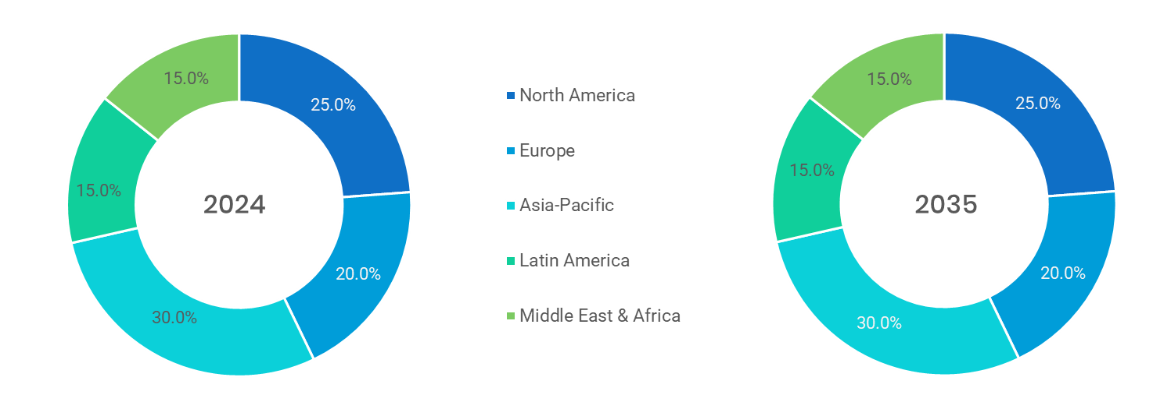
Source: Primary Interviews, Surveys, Secondary Sources, Web-Based & Paid External Databases, 2025
Note: Charts & Figures only for Illustration purposes
- {{report_geography}} {{market_name_upper}} Market, by {{seg4_name}}, 2020 – 2035 (USD MILLION)
By {{seg4_name}} | {{history_start_year}} | 2021 | 2022 | 2023 | {{base_year}} | {{forecast_start_year}} | 2026 | 2027 | 2028 | 2029 | 2030 | 2031 | 2032 | 2033 | 2034 | {{forecast_end_year}} | CAGR%  (2025-2035)
{{seg4_sub1}} | XX | XX | XX | XX | XX | XX | XX | XX | XX | XX | XX | XX | XX | XX | XX | XX | XX
{{seg4_sub2}} | XX | XX | XX | XX | XX | XX | XX | XX | XX | XX | XX | XX | XX | XX | XX | XX | XX
{{seg4_sub3}} | XX | XX | XX | XX | XX | XX | XX | XX | XX | XX | XX | XX | XX | XX | XX | XX | XX
Sub-{{seg4_name}} | XX | XX | XX | XX | XX | XX | XX | XX | XX | XX | XX | XX | XX | XX | XX | XX | XX
Total | XX | XX | XX | XX | XX | XX | XX | XX | XX | XX | XX | XX | XX | XX | XX | XX | XX
Source: Primary Interviews, Surveys, Secondary Sources, Web-Based & Paid External Databases, 2025

  - {{seg4_sub1}}
    - {{report_geography}} {{market_name_upper}} Market by {{seg4_sub1}}, 2020 - 2035 (USD MILLION)
- {{report_geography}} {{market_name_upper}} Market by {{seg4_sub1}}, 2020 – 2035 (USD MILLION)
Source: Primary Interviews, Surveys, Secondary Sources, Web-Based & Paid External Databases, 2025

- {{report_geography}} {{market_name_upper}} Market by {{seg4_sub1}}, by Region, 2020 – 2035 (USD MILLION)
By Region | {{history_start_year}} | 2021 | 2022 | 2023 | {{base_year}} | {{forecast_start_year}} | 2026 | 2027 | 2028 | 2029 | 2030 | 2031 | 2032 | 2033 | 2034 | {{forecast_end_year}} | CAGR%  (2025-2035)
North America | XX | XX | XX | XX | XX | XX | XX | XX | XX | XX | XX | XX | XX | XX | XX | XX | XX
Europe | XX | XX | XX | XX | XX | XX | XX | XX | XX | XX | XX | XX | XX | XX | XX | XX | XX
Asia-Pacific | XX | XX | XX | XX | XX | XX | XX | XX | XX | XX | XX | XX | XX | XX | XX | XX | XX
Latin America | XX | XX | XX | XX | XX | XX | XX | XX | XX | XX | XX | XX | XX | XX | XX | XX | XX
Middle East & Africa | XX | XX | XX | XX | XX | XX | XX | XX | XX | XX | XX | XX | XX | XX | XX | XX | XX
Total | XX | XX | XX | XX | XX | XX | XX | XX | XX | XX | XX | XX | XX | XX | XX | XX | XX
Source: Primary Interviews, Surveys, Secondary Sources, Web-Based & Paid External Databases, 2025
*The above similar information will be cover for below segment as well.
  - {{seg4_sub2}}
  - {{seg4_sub3}}
  - Sub-{{seg4_name}}
X
X

- {{market_name_upper}} Market –{{seg5_name}} Analysis
  - {{report_geography}} {{market_name_upper}} Market –{{seg5_name}} Overview

  - {{report_geography}} {{market_name_upper}} Market Share, by {{seg5_name}}, 2024 & 2035 (%)
- {{report_geography}} {{market_name_upper}} Market Share, by {{seg5_name}}, 2024 & 2035 (%)
Source: Primary Interviews, Surveys, Secondary Sources, Web-Based & Paid External Databases, 2025
Note: Charts & Figures only for Illustration purposes
- {{report_geography}} {{market_name_upper}} Market, by {{seg5_name}}, 2020 – 2035 (USD MILLION)
By {{seg5_name}} | {{history_start_year}} | 2021 | 2022 | 2023 | {{base_year}} | {{forecast_start_year}} | 2026 | 2027 | 2028 | 2029 | 2030 | 2031 | 2032 | 2033 | 2034 | {{forecast_end_year}} | CAGR%  (2025-2035)
{{seg5_sub1}} | XX | XX | XX | XX | XX | XX | XX | XX | XX | XX | XX | XX | XX | XX | XX | XX | XX
{{seg5_sub2}} | XX | XX | XX | XX | XX | XX | XX | XX | XX | XX | XX | XX | XX | XX | XX | XX | XX
{{seg5_sub3}} | XX | XX | XX | XX | XX | XX | XX | XX | XX | XX | XX | XX | XX | XX | XX | XX | XX
Sub-{{seg5_name}} | XX | XX | XX | XX | XX | XX | XX | XX | XX | XX | XX | XX | XX | XX | XX | XX | XX
Total | XX | XX | XX | XX | XX | XX | XX | XX | XX | XX | XX | XX | XX | XX | XX | XX | XX
Source: Primary Interviews, Surveys, Secondary Sources, Web-Based & Paid External Databases, 2025

  - {{seg5_sub1}}
    - {{report_geography}} {{market_name_upper}} Market by {{seg5_sub1}}, 2020 - 2035 (USD MILLION)
- {{report_geography}} {{market_name_upper}} Market by {{seg5_sub1}}, 2020 – 2035 (USD MILLION)
Source: Primary Interviews, Surveys, Secondary Sources, Web-Based & Paid External Databases, 2025

- {{report_geography}} {{market_name_upper}} Market by {{seg5_sub1}}, by Region, 2020 – 2035 (USD MILLION)
By Region | {{history_start_year}} | 2021 | 2022 | 2023 | {{base_year}} | {{forecast_start_year}} | 2026 | 2027 | 2028 | 2029 | 2030 | 2031 | 2032 | 2033 | 2034 | {{forecast_end_year}} | CAGR%  (2025-2035)
North America | XX | XX | XX | XX | XX | XX | XX | XX | XX | XX | XX | XX | XX | XX | XX | XX | XX
Europe | XX | XX | XX | XX | XX | XX | XX | XX | XX | XX | XX | XX | XX | XX | XX | XX | XX
Asia-Pacific | XX | XX | XX | XX | XX | XX | XX | XX | XX | XX | XX | XX | XX | XX | XX | XX | XX
Latin America | XX | XX | XX | XX | XX | XX | XX | XX | XX | XX | XX | XX | XX | XX | XX | XX | XX
Middle East & Africa | XX | XX | XX | XX | XX | XX | XX | XX | XX | XX | XX | XX | XX | XX | XX | XX | XX
Total | XX | XX | XX | XX | XX | XX | XX | XX | XX | XX | XX | XX | XX | XX | XX | XX | XX
Source: Primary Interviews, Surveys, Secondary Sources, Web-Based & Paid External Databases, 2025
*The above similar information will be cover for below segment as well.
  - {{seg5_sub2}}
  - {{seg5_sub3}}
  - Sub-{{seg5_name}}

- {{market_name_upper}} Market –{{seg6_name}} Analysis
  - {{report_geography}} {{market_name_upper}} Market –{{seg6_name}} Overview

  - {{report_geography}} {{market_name_upper}} Market Share, by {{seg6_name}}, 2024 & 2035 (%)
- {{report_geography}} {{market_name_upper}} Market Share, by {{seg6_name}}, 2024 & 2035 (%)
Source: Primary Interviews, Surveys, Secondary Sources, Web-Based & Paid External Databases, 2025
Note: Charts & Figures only for Illustration purposes
- {{report_geography}} {{market_name_upper}} Market, by {{seg6_name}}, 2020 – 2035 (USD MILLION)
By {{seg5_name}} | {{history_start_year}} | 2021 | 2022 | 2023 | {{base_year}} | {{forecast_start_year}} | 2026 | 2027 | 2028 | 2029 | 2030 | 2031 | 2032 | 2033 | 2034 | {{forecast_end_year}} | CAGR%  (2025-2035)
{{seg6_sub1}} | XX | XX | XX | XX | XX | XX | XX | XX | XX | XX | XX | XX | XX | XX | XX | XX | XX
{{seg6_sub2}} | XX | XX | XX | XX | XX | XX | XX | XX | XX | XX | XX | XX | XX | XX | XX | XX | XX
{{seg6_sub3}} | XX | XX | XX | XX | XX | XX | XX | XX | XX | XX | XX | XX | XX | XX | XX | XX | XX
Sub-{{seg6_name}} | XX | XX | XX | XX | XX | XX | XX | XX | XX | XX | XX | XX | XX | XX | XX | XX | XX
Total | XX | XX | XX | XX | XX | XX | XX | XX | XX | XX | XX | XX | XX | XX | XX | XX | XX
Source: Primary Interviews, Surveys, Secondary Sources, Web-Based & Paid External Databases, 2025

  - {{seg6_sub1}}
    - {{report_geography}} {{market_name_upper}} Market by {{seg6_sub1}}, 2020 - 2035 (USD MILLION)
- {{report_geography}} {{market_name_upper}} Market by {{seg6_sub1}}, 2020 – 2035 (USD MILLION)
Source: Primary Interviews, Surveys, Secondary Sources, Web-Based & Paid External Databases, 2025

- {{report_geography}} {{market_name_upper}} Market by {{seg6_sub1}}, by Region, 2020 – 2035 (USD MILLION)
By Region | {{history_start_year}} | 2021 | 2022 | 2023 | {{base_year}} | {{forecast_start_year}} | 2026 | 2027 | 2028 | 2029 | 2030 | 2031 | 2032 | 2033 | 2034 | {{forecast_end_year}} | CAGR%  (2025-2035)
North America | XX | XX | XX | XX | XX | XX | XX | XX | XX | XX | XX | XX | XX | XX | XX | XX | XX
Europe | XX | XX | XX | XX | XX | XX | XX | XX | XX | XX | XX | XX | XX | XX | XX | XX | XX
Asia-Pacific | XX | XX | XX | XX | XX | XX | XX | XX | XX | XX | XX | XX | XX | XX | XX | XX | XX
Latin America | XX | XX | XX | XX | XX | XX | XX | XX | XX | XX | XX | XX | XX | XX | XX | XX | XX
Middle East & Africa | XX | XX | XX | XX | XX | XX | XX | XX | XX | XX | XX | XX | XX | XX | XX | XX | XX
Total | XX | XX | XX | XX | XX | XX | XX | XX | XX | XX | XX | XX | XX | XX | XX | XX | XX
Source: Primary Interviews, Surveys, Secondary Sources, Web-Based & Paid External Databases, 2025
*The above similar information will be cover for below segment as well.
  - {{seg6_sub2}}
  - {{seg6_sub3}}
  - Sub-{{seg6_name}}

- {{market_name_upper}} Market – Regional Analysis
  - {{report_geography}} {{market_name_upper}} Market Regional Overview

  - {{report_geography}} {{market_name_upper}} Market Share, by Region, 2024 & 2035 (%)
- {{report_geography}} {{market_name_upper}} Market Share, by Region, 2024 & 2035 (%)
Source: Primary Interviews, Surveys, Secondary Sources, Web-Based & Paid External Databases, 2025
Note: Charts & Figures are only for Illustration purposes
- {{report_geography}} {{market_name_upper}} Market, by Region, 2020 – 2035 (USD MILLION)
By Region | {{history_start_year}} | 2021 | 2022 | 2023 | {{base_year}} | {{forecast_start_year}} | 2026 | 2027 | 2028 | 2029 | 2030 | 2031 | 2032 | 2033 | 2034 | {{forecast_end_year}} | CAGR%  (2025-2035)
North America | XX | XX | XX | XX | XX | XX | XX | XX | XX | XX | XX | XX | XX | XX | XX | XX | XX
Europe | XX | XX | XX | XX | XX | XX | XX | XX | XX | XX | XX | XX | XX | XX | XX | XX | XX
Asia-Pacific | XX | XX | XX | XX | XX | XX | XX | XX | XX | XX | XX | XX | XX | XX | XX | XX | XX
Latin America | XX | XX | XX | XX | XX | XX | XX | XX | XX | XX | XX | XX | XX | XX | XX | XX | XX
Middle East & Africa | XX | XX | XX | XX | XX | XX | XX | XX | XX | XX | XX | XX | XX | XX | XX | XX | XX
Total | XX | XX | XX | XX | XX | XX | XX | XX | XX | XX | XX | XX | XX | XX | XX | XX | XX
Source: Primary Interviews, Surveys, Secondary Sources, Web-Based & Paid External Databases, 2025

  - North America
    - North America {{market_name_upper}} Market, 2020 - 2035 (USD MILLION)
- North America {{market_name_upper}} Market, 2020 - 2035 (USD MILLION)
Source: Primary Interviews, Surveys, Secondary Sources, Web-Based & Paid External Databases, 2025

    - North America {{market_name_upper}} Market, by Country, 2020 – 2035 (USD MILLION)
- North America {{market_name_upper}} Market, by Country, 2020 – 2035 (USD MILLION)
By Country | {{history_start_year}} | 2021 | 2022 | 2023 | {{base_year}} | {{forecast_start_year}} | 2026 | 2027 | 2028 | 2029 | 2030 | 2031 | 2032 | 2033 | 2034 | {{forecast_end_year}} | CAGR%  (2025-2035)
U.S. | XX | XX | XX | XX | XX | XX | XX | XX | XX | XX | XX | XX | XX | XX | XX | XX | XX
Canada | XX | XX | XX | XX | XX | XX | XX | XX | XX | XX | XX | XX | XX | XX | XX | XX | XX
Mexico | XX | XX | XX | XX | XX | XX | XX | XX | XX | XX | XX | XX | XX | XX | XX | XX | XX
Total | XX | XX | XX | XX | XX | XX | XX | XX | XX | XX | XX | XX | XX | XX | XX | XX | XX
Source: Primary Interviews, Surveys, Secondary Sources, Web-Based & Paid External Databases, 2025

    - North America {{market_name_upper}} Market, by Type, 2020 – 2035 (USD MILLION)
- North America {{market_name_upper}} Market, by Type, 2020 – 2035 (USD MILLION)
By Type | {{history_start_year}} | 2021 | 2022 | 2023 | {{base_year}} | {{forecast_start_year}} | 2026 | 2027 | 2028 | 2029 | 2030 | 2031 | 2032 | 2033 | 2034 | 20235 | CAGR%  (2025-2035)
{{type_segment_1}} | XX | XX | XX | XX | XX | XX | XX | XX | XX | XX | XX | XX | XX | XX | XX | XX | XX
{{type_segment_2}} | XX | XX | XX | XX | XX | XX | XX | XX | XX | XX | XX | XX | XX | XX | XX | XX | XX
{{type_segment_3}} | XX | XX | XX | XX | XX | XX | XX | XX | XX | XX | XX | XX | XX | XX | XX | XX | XX
Total | XX | XX | XX | XX | XX | XX | XX | XX | XX | XX | XX | XX | XX | XX | XX | XX | XX
Source: Primary Interviews, Surveys, Secondary Sources, Web-Based & Paid External Databases, 2025

    - North America {{market_name_upper}} Market, by Technology, 2020 – 2035 (USD MILLION)
- North America {{market_name_upper}} Market, by Technology, 2020 – 2035 (USD MILLION)
By TECHNOLOGY | {{history_start_year}} | 2021 | 2022 | 2023 | {{base_year}} | {{forecast_start_year}} | 2026 | 2027 | 2028 | 2029 | 2030 | 2031 | 2032 | 2033 | 2034 | {{forecast_end_year}} | CAGR%  (2025-2035)
{{tech_segment_1}} | XX | XX | XX | XX | XX | XX | XX | XX | XX | XX | XX | XX | XX | XX | XX | XX | XX
{{tech_segment_2}} | XX | XX | XX | XX | XX | XX | XX | XX | XX | XX | XX | XX | XX | XX | XX | XX | XX
{{tech_segment_3}} | XX | XX | XX | XX | XX | XX | XX | XX | XX | XX | XX | XX | XX | XX | XX | XX | XX
Total | XX | XX | XX | XX | XX | XX | XX | XX | XX | XX | XX | XX | XX | XX | XX | XX | XX
Source: Primary Interviews, Surveys, Secondary Sources, Web-Based & Paid External Databases, 2025

    - North America {{market_name_upper}} Market, by Application, 2020 – 2035 (USD MILLION)
- North America {{market_name_upper}} Market, by Application, 2020 – 2035 (USD MILLION)
By Application | {{history_start_year}} | 2021 | 2022 | 2023 | {{base_year}} | {{forecast_start_year}} | 2026 | 2027 | 2028 | 2029 | 2030 | 2031 | 2032 | 2033 | 2034 | {{forecast_end_year}} | CAGR%  (2025-2035)
{{app_segment_1}} | XX | XX | XX | XX | XX | XX | XX | XX | XX | XX | XX | XX | XX | XX | XX | XX | XX
{{app_segment_4}} | XX | XX | XX | XX | XX | XX | XX | XX | XX | XX | XX | XX | XX | XX | XX | XX | XX
{{app_segment_2}} | XX | XX | XX | XX | XX | XX | XX | XX | XX | XX | XX | XX | XX | XX | XX | XX | XX
{{app_segment_3}} | XX | XX | XX | XX | XX | XX | XX | XX | XX | XX | XX | XX | XX | XX | XX | XX | XX
Total | XX | XX | XX | XX | XX | XX | XX | XX | XX | XX | XX | XX | XX | XX | XX | XX | XX
Source: Primary Interviews, Surveys, Secondary Sources, Web-Based & Paid External Databases, 2025
    - North America {{market_name_upper}} Market, by {{seg4_name}}, 2020 – 2035 (USD MILLION)
- North America {{market_name_upper}} Market, by {{seg4_name}}, 2020 – 2035 (USD MILLION)
By Application | {{history_start_year}} | 2021 | 2022 | 2023 | {{base_year}} | {{forecast_start_year}} | 2026 | 2027 | 2028 | 2029 | 2030 | 2031 | 2032 | 2033 | 2034 | {{forecast_end_year}} | CAGR%  (2025-2035)
{{app_segment_1}} | XX | XX | XX | XX | XX | XX | XX | XX | XX | XX | XX | XX | XX | XX | XX | XX | XX
{{app_segment_4}} | XX | XX | XX | XX | XX | XX | XX | XX | XX | XX | XX | XX | XX | XX | XX | XX | XX
{{app_segment_2}} | XX | XX | XX | XX | XX | XX | XX | XX | XX | XX | XX | XX | XX | XX | XX | XX | XX
{{app_segment_3}} | XX | XX | XX | XX | XX | XX | XX | XX | XX | XX | XX | XX | XX | XX | XX | XX | XX
Total | XX | XX | XX | XX | XX | XX | XX | XX | XX | XX | XX | XX | XX | XX | XX | XX | XX
Source: Primary Interviews, Surveys, Secondary Sources, Web-Based & Paid External Databases, 2025
    - North America {{market_name_upper}} Market, by {{seg5_name}}, 2020 – 2035 (USD MILLION)
- North America {{market_name_upper}} Market, by {{seg5_name}}, 2020 – 2035 (USD MILLION)
By Application | {{history_start_year}} | 2021 | 2022 | 2023 | {{base_year}} | {{forecast_start_year}} | 2026 | 2027 | 2028 | 2029 | 2030 | 2031 | 2032 | 2033 | 2034 | {{forecast_end_year}} | CAGR%  (2025-2035)
{{app_segment_1}} | XX | XX | XX | XX | XX | XX | XX | XX | XX | XX | XX | XX | XX | XX | XX | XX | XX
{{app_segment_4}} | XX | XX | XX | XX | XX | XX | XX | XX | XX | XX | XX | XX | XX | XX | XX | XX | XX
{{app_segment_2}} | XX | XX | XX | XX | XX | XX | XX | XX | XX | XX | XX | XX | XX | XX | XX | XX | XX
{{app_segment_3}} | XX | XX | XX | XX | XX | XX | XX | XX | XX | XX | XX | XX | XX | XX | XX | XX | XX
Total | XX | XX | XX | XX | XX | XX | XX | XX | XX | XX | XX | XX | XX | XX | XX | XX | XX
Source: Primary Interviews, Surveys, Secondary Sources, Web-Based & Paid External Databases, 2025
    - North America {{market_name_upper}} Market, by {{seg6_name}}, 2020 – 2035 (USD MILLION)
- North America {{market_name_upper}} Market, by {{seg6_name}}, 2020 – 2035 (USD MILLION)
By Application | {{history_start_year}} | 2021 | 2022 | 2023 | {{base_year}} | {{forecast_start_year}} | 2026 | 2027 | 2028 | 2029 | 2030 | 2031 | 2032 | 2033 | 2034 | {{forecast_end_year}} | CAGR%  (2025-2035)
{{app_segment_1}} | XX | XX | XX | XX | XX | XX | XX | XX | XX | XX | XX | XX | XX | XX | XX | XX | XX
{{app_segment_4}} | XX | XX | XX | XX | XX | XX | XX | XX | XX | XX | XX | XX | XX | XX | XX | XX | XX
{{app_segment_2}} | XX | XX | XX | XX | XX | XX | XX | XX | XX | XX | XX | XX | XX | XX | XX | XX | XX
{{app_segment_3}} | XX | XX | XX | XX | XX | XX | XX | XX | XX | XX | XX | XX | XX | XX | XX | XX | XX
Total | XX | XX | XX | XX | XX | XX | XX | XX | XX | XX | XX | XX | XX | XX | XX | XX | XX
Source: Primary Interviews, Surveys, Secondary Sources, Web-Based & Paid External Databases, 2025
    - U.S.
- U.S. {{market_name_upper}} Market, 2020 – 2035 (USD MILLION)
Source: Primary Interviews, Surveys, Secondary Sources, Web-Based & Paid External Databases, 2025

      - U.S. {{market_name_upper}} Market, by Type, 2020 – 2035 (USD MILLION)
- U.S. {{market_name_upper}} Market, by Type, 2020 – 2035 (USD MILLION)
By Type | {{history_start_year}} | 2021 | 2022 | 2023 | {{base_year}} | {{forecast_start_year}} | 2026 | 2027 | 2028 | 2029 | 2030 | 2031 | 2032 | 2033 | 2034 | 20235 | CAGR%  (2025-2035)
{{type_segment_1}} | XX | XX | XX | XX | XX | XX | XX | XX | XX | XX | XX | XX | XX | XX | XX | XX | XX
{{type_segment_2}} | XX | XX | XX | XX | XX | XX | XX | XX | XX | XX | XX | XX | XX | XX | XX | XX | XX
{{type_segment_3}} | XX | XX | XX | XX | XX | XX | XX | XX | XX | XX | XX | XX | XX | XX | XX | XX | XX
Total | XX | XX | XX | XX | XX | XX | XX | XX | XX | XX | XX | XX | XX | XX | XX | XX | XX
Source: Primary Interviews, Surveys, Secondary Sources, Web-Based & Paid External Databases, 2025

      - U.S. {{market_name_upper}} Market, by TECHNOLOGY, 2020 – 2035 (USD MILLION)
- U.S. {{market_name_upper}} Market, by TECHNOLOGY, 2020 – 2035 (USD MILLION)
By TECHNOLOGY | {{history_start_year}} | 2021 | 2022 | 2023 | {{base_year}} | {{forecast_start_year}} | 2026 | 2027 | 2028 | 2029 | 2030 | 2031 | 2032 | 2033 | 2034 | {{forecast_end_year}} | CAGR%  (2025-2035)
{{tech_segment_1}} | XX | XX | XX | XX | XX | XX | XX | XX | XX | XX | XX | XX | XX | XX | XX | XX | XX
{{tech_segment_2}} | XX | XX | XX | XX | XX | XX | XX | XX | XX | XX | XX | XX | XX | XX | XX | XX | XX
{{tech_segment_3}} | XX | XX | XX | XX | XX | XX | XX | XX | XX | XX | XX | XX | XX | XX | XX | XX | XX
Total | XX | XX | XX | XX | XX | XX | XX | XX | XX | XX | XX | XX | XX | XX | XX | XX | XX
Source: Primary Interviews, Surveys, Secondary Sources, Web-Based & Paid External Databases, 2025

      - U.S. {{market_name_upper}} Market, by Application, 2020 – 2035 (USD MILLION)
- U.S. {{market_name_upper}} Market, by Application, 2020 – 2035 (USD MILLION)
By Application | {{history_start_year}} | 2021 | 2022 | 2023 | {{base_year}} | {{forecast_start_year}} | 2026 | 2027 | 2028 | 2029 | 2030 | 2031 | 2032 | 2033 | 2034 | {{forecast_end_year}} | CAGR%  (2025-2035)
{{app_segment_1}} | XX | XX | XX | XX | XX | XX | XX | XX | XX | XX | XX | XX | XX | XX | XX | XX | XX
{{app_segment_4}} | XX | XX | XX | XX | XX | XX | XX | XX | XX | XX | XX | XX | XX | XX | XX | XX | XX
{{app_segment_2}} | XX | XX | XX | XX | XX | XX | XX | XX | XX | XX | XX | XX | XX | XX | XX | XX | XX
{{app_segment_3}} | XX | XX | XX | XX | XX | XX | XX | XX | XX | XX | XX | XX | XX | XX | XX | XX | XX
Total | XX | XX | XX | XX | XX | XX | XX | XX | XX | XX | XX | XX | XX | XX | XX | XX | XX
Source: Primary Interviews, Surveys, Secondary Sources, Web-Based & Paid External Databases, 2025
      - U.S. {{market_name_upper}} Market, by {{seg4_name}}, 2020 – 2035 (USD MILLION)
- U.S. {{market_name_upper}} Market, by {{seg4_name}}, 2020 – 2035 (USD MILLION)
By Application | {{history_start_year}} | 2021 | 2022 | 2023 | {{base_year}} | {{forecast_start_year}} | 2026 | 2027 | 2028 | 2029 | 2030 | 2031 | 2032 | 2033 | 2034 | {{forecast_end_year}} | CAGR%  (2025-2035)
{{app_segment_1}} | XX | XX | XX | XX | XX | XX | XX | XX | XX | XX | XX | XX | XX | XX | XX | XX | XX
{{app_segment_4}} | XX | XX | XX | XX | XX | XX | XX | XX | XX | XX | XX | XX | XX | XX | XX | XX | XX
{{app_segment_2}} | XX | XX | XX | XX | XX | XX | XX | XX | XX | XX | XX | XX | XX | XX | XX | XX | XX
{{app_segment_3}} | XX | XX | XX | XX | XX | XX | XX | XX | XX | XX | XX | XX | XX | XX | XX | XX | XX
Total | XX | XX | XX | XX | XX | XX | XX | XX | XX | XX | XX | XX | XX | XX | XX | XX | XX
Source: Primary Interviews, Surveys, Secondary Sources, Web-Based & Paid External Databases, 2025
      - U.S. {{market_name_upper}} Market, by {{seg5_name}}, 2020 – 2035 (USD MILLION)
- U.S. {{market_name_upper}} Market, by {{seg5_name}}, 2020 – 2035 (USD MILLION)
By Application | {{history_start_year}} | 2021 | 2022 | 2023 | {{base_year}} | {{forecast_start_year}} | 2026 | 2027 | 2028 | 2029 | 2030 | 2031 | 2032 | 2033 | 2034 | {{forecast_end_year}} | CAGR%  (2025-2035)
{{app_segment_1}} | XX | XX | XX | XX | XX | XX | XX | XX | XX | XX | XX | XX | XX | XX | XX | XX | XX
{{app_segment_4}} | XX | XX | XX | XX | XX | XX | XX | XX | XX | XX | XX | XX | XX | XX | XX | XX | XX
{{app_segment_2}} | XX | XX | XX | XX | XX | XX | XX | XX | XX | XX | XX | XX | XX | XX | XX | XX | XX
{{app_segment_3}} | XX | XX | XX | XX | XX | XX | XX | XX | XX | XX | XX | XX | XX | XX | XX | XX | XX
Total | XX | XX | XX | XX | XX | XX | XX | XX | XX | XX | XX | XX | XX | XX | XX | XX | XX
Source: Primary Interviews, Surveys, Secondary Sources, Web-Based & Paid External Databases, 2025
      - U.S. {{market_name_upper}} Market, by {{seg6_name}}, 2020 – 2035 (USD MILLION)
- U.S. {{market_name_upper}} Market, by {{seg6_name}}, 2020 – 2035 (USD MILLION)
By Application | {{history_start_year}} | 2021 | 2022 | 2023 | {{base_year}} | {{forecast_start_year}} | 2026 | 2027 | 2028 | 2029 | 2030 | 2031 | 2032 | 2033 | 2034 | {{forecast_end_year}} | CAGR%  (2025-2035)
{{app_segment_1}} | XX | XX | XX | XX | XX | XX | XX | XX | XX | XX | XX | XX | XX | XX | XX | XX | XX
{{app_segment_4}} | XX | XX | XX | XX | XX | XX | XX | XX | XX | XX | XX | XX | XX | XX | XX | XX | XX
{{app_segment_2}} | XX | XX | XX | XX | XX | XX | XX | XX | XX | XX | XX | XX | XX | XX | XX | XX | XX
{{app_segment_3}} | XX | XX | XX | XX | XX | XX | XX | XX | XX | XX | XX | XX | XX | XX | XX | XX | XX
Total | XX | XX | XX | XX | XX | XX | XX | XX | XX | XX | XX | XX | XX | XX | XX | XX | XX
Source: Primary Interviews, Surveys, Secondary Sources, Web-Based & Paid External Databases, 2025
    - Canada
- Canada {{market_name_upper}} Market, 2020 – 2035 (USD MILLION)
Source: Primary Interviews, Surveys, Secondary Sources, Web-Based & Paid External Databases, 2025

      - CANADA {{market_name_upper}} Market, by Type, 2020 – 2035 (USD MILLION)
- CANADA {{market_name_upper}} Market, by Type, 2020 – 2035 (USD MILLION)
By Type | {{history_start_year}} | 2021 | 2022 | 2023 | {{base_year}} | {{forecast_start_year}} | 2026 | 2027 | 2028 | 2029 | 2030 | 2031 | 2032 | 2033 | 2034 | 20235 | CAGR%  (2025-2035)
{{type_segment_1}} | XX | XX | XX | XX | XX | XX | XX | XX | XX | XX | XX | XX | XX | XX | XX | XX | XX
{{type_segment_2}} | XX | XX | XX | XX | XX | XX | XX | XX | XX | XX | XX | XX | XX | XX | XX | XX | XX
{{type_segment_3}} | XX | XX | XX | XX | XX | XX | XX | XX | XX | XX | XX | XX | XX | XX | XX | XX | XX
Total | XX | XX | XX | XX | XX | XX | XX | XX | XX | XX | XX | XX | XX | XX | XX | XX | XX
Source: Primary Interviews, Surveys, Secondary Sources, Web-Based & Paid External Databases, 2025
      - CANADA {{market_name_upper}} Market, by TECHNOLOGY, 2020 – 2035 (USD MILLION)
- CANADA {{market_name_upper}} Market, by TECHNOLOGY, 2020 – 2035 (USD MILLION)
By TECHNOLOGY | {{history_start_year}} | 2021 | 2022 | 2023 | {{base_year}} | {{forecast_start_year}} | 2026 | 2027 | 2028 | 2029 | 2030 | 2031 | 2032 | 2033 | 2034 | {{forecast_end_year}} | CAGR%  (2025-2035)
{{tech_segment_1}} | XX | XX | XX | XX | XX | XX | XX | XX | XX | XX | XX | XX | XX | XX | XX | XX | XX
{{tech_segment_2}} | XX | XX | XX | XX | XX | XX | XX | XX | XX | XX | XX | XX | XX | XX | XX | XX | XX
{{tech_segment_3}} | XX | XX | XX | XX | XX | XX | XX | XX | XX | XX | XX | XX | XX | XX | XX | XX | XX
Total | XX | XX | XX | XX | XX | XX | XX | XX | XX | XX | XX | XX | XX | XX | XX | XX | XX
Source: Primary Interviews, Surveys, Secondary Sources, Web-Based & Paid External Databases, 2025

      - CANADA {{market_name_upper}} Market, by Application, 2020 – 2035 (USD MILLION)
- CANADA {{market_name_upper}} Market, by Application, 2020 – 2035 (USD MILLION)
By Application | {{history_start_year}} | 2021 | 2022 | 2023 | {{base_year}} | {{forecast_start_year}} | 2026 | 2027 | 2028 | 2029 | 2030 | 2031 | 2032 | 2033 | 2034 | {{forecast_end_year}} | CAGR%  (2025-2035)
{{app_segment_1}} | XX | XX | XX | XX | XX | XX | XX | XX | XX | XX | XX | XX | XX | XX | XX | XX | XX
{{app_segment_4}} | XX | XX | XX | XX | XX | XX | XX | XX | XX | XX | XX | XX | XX | XX | XX | XX | XX
{{app_segment_2}} | XX | XX | XX | XX | XX | XX | XX | XX | XX | XX | XX | XX | XX | XX | XX | XX | XX
{{app_segment_3}} | XX | XX | XX | XX | XX | XX | XX | XX | XX | XX | XX | XX | XX | XX | XX | XX | XX
Total | XX | XX | XX | XX | XX | XX | XX | XX | XX | XX | XX | XX | XX | XX | XX | XX | XX
Source: Primary Interviews, Surveys, Secondary Sources, Web-Based & Paid External Databases, 2025
      - CANADA {{market_name_upper}} Market, by {{seg4_name}}, 2020 – 2035 (USD MILLION)
- CANADA {{market_name_upper}} Market, by {{seg4_name}}, 2020 – 2035 (USD MILLION)
By Application | {{history_start_year}} | 2021 | 2022 | 2023 | {{base_year}} | {{forecast_start_year}} | 2026 | 2027 | 2028 | 2029 | 2030 | 2031 | 2032 | 2033 | 2034 | {{forecast_end_year}} | CAGR%  (2025-2035)
{{app_segment_1}} | XX | XX | XX | XX | XX | XX | XX | XX | XX | XX | XX | XX | XX | XX | XX | XX | XX
{{app_segment_4}} | XX | XX | XX | XX | XX | XX | XX | XX | XX | XX | XX | XX | XX | XX | XX | XX | XX
{{app_segment_2}} | XX | XX | XX | XX | XX | XX | XX | XX | XX | XX | XX | XX | XX | XX | XX | XX | XX
{{app_segment_3}} | XX | XX | XX | XX | XX | XX | XX | XX | XX | XX | XX | XX | XX | XX | XX | XX | XX
Total | XX | XX | XX | XX | XX | XX | XX | XX | XX | XX | XX | XX | XX | XX | XX | XX | XX
Source: Primary Interviews, Surveys, Secondary Sources, Web-Based & Paid External Databases, 2025
      - CANADA {{market_name_upper}} Market, by {{seg5_name}}, 2020 – 2035 (USD MILLION)
- CANADA {{market_name_upper}} Market, by {{seg5_name}}, 2020 – 2035 (USD MILLION)
By Application | {{history_start_year}} | 2021 | 2022 | 2023 | {{base_year}} | {{forecast_start_year}} | 2026 | 2027 | 2028 | 2029 | 2030 | 2031 | 2032 | 2033 | 2034 | {{forecast_end_year}} | CAGR%  (2025-2035)
{{app_segment_1}} | XX | XX | XX | XX | XX | XX | XX | XX | XX | XX | XX | XX | XX | XX | XX | XX | XX
{{app_segment_4}} | XX | XX | XX | XX | XX | XX | XX | XX | XX | XX | XX | XX | XX | XX | XX | XX | XX
{{app_segment_2}} | XX | XX | XX | XX | XX | XX | XX | XX | XX | XX | XX | XX | XX | XX | XX | XX | XX
{{app_segment_3}} | XX | XX | XX | XX | XX | XX | XX | XX | XX | XX | XX | XX | XX | XX | XX | XX | XX
Total | XX | XX | XX | XX | XX | XX | XX | XX | XX | XX | XX | XX | XX | XX | XX | XX | XX
Source: Primary Interviews, Surveys, Secondary Sources, Web-Based & Paid External Databases, 2025
      - CANADA {{market_name_upper}} Market, by {{seg6_name}}, 2020 – 2035 (USD MILLION)
- CANADA {{market_name_upper}} Market, by {{seg6_name}}, 2020 – 2035 (USD MILLION)
By Application | {{history_start_year}} | 2021 | 2022 | 2023 | {{base_year}} | {{forecast_start_year}} | 2026 | 2027 | 2028 | 2029 | 2030 | 2031 | 2032 | 2033 | 2034 | {{forecast_end_year}} | CAGR%  (2025-2035)
{{app_segment_1}} | XX | XX | XX | XX | XX | XX | XX | XX | XX | XX | XX | XX | XX | XX | XX | XX | XX
{{app_segment_4}} | XX | XX | XX | XX | XX | XX | XX | XX | XX | XX | XX | XX | XX | XX | XX | XX | XX
{{app_segment_2}} | XX | XX | XX | XX | XX | XX | XX | XX | XX | XX | XX | XX | XX | XX | XX | XX | XX
{{app_segment_3}} | XX | XX | XX | XX | XX | XX | XX | XX | XX | XX | XX | XX | XX | XX | XX | XX | XX
Total | XX | XX | XX | XX | XX | XX | XX | XX | XX | XX | XX | XX | XX | XX | XX | XX | XX
Source: Primary Interviews, Surveys, Secondary Sources, Web-Based & Paid External Databases, 2025
    - Mexico
- Mexico {{market_name_upper}} Market, 2020 – 2035 (USD MILLION)
Source: Primary Interviews, Surveys, Secondary Sources, Web-Based & Paid External Databases, 2025

      - MEXICO {{market_name_upper}} Market, by Type, 2020 – 2035 (USD MILLION)
- MEXICO {{market_name_upper}} Market, by Type, 2020 – 2035 (USD MILLION)
By Type | {{history_start_year}} | 2021 | 2022 | 2023 | {{base_year}} | {{forecast_start_year}} | 2026 | 2027 | 2028 | 2029 | 2030 | 2031 | 2032 | 2033 | 2034 | 20235 | CAGR%  (2025-2035)
{{type_segment_1}} | XX | XX | XX | XX | XX | XX | XX | XX | XX | XX | XX | XX | XX | XX | XX | XX | XX
{{type_segment_2}} | XX | XX | XX | XX | XX | XX | XX | XX | XX | XX | XX | XX | XX | XX | XX | XX | XX
{{type_segment_3}} | XX | XX | XX | XX | XX | XX | XX | XX | XX | XX | XX | XX | XX | XX | XX | XX | XX
Total | XX | XX | XX | XX | XX | XX | XX | XX | XX | XX | XX | XX | XX | XX | XX | XX | XX
Source: Primary Interviews, Surveys, Secondary Sources, Web-Based & Paid External Databases, 2025
      - MEXICO {{market_name_upper}} Market, by TECHNOLOGY, 2020 – 2035 (USD MILLION)
- MEXICO {{market_name_upper}} Market, by TECHNOLOGY, 2020 – 2035 (USD MILLION)
By TECHNOLOGY | {{history_start_year}} | 2021 | 2022 | 2023 | {{base_year}} | {{forecast_start_year}} | 2026 | 2027 | 2028 | 2029 | 2030 | 2031 | 2032 | 2033 | 2034 | {{forecast_end_year}} | CAGR%  (2025-2035)
{{tech_segment_1}} | XX | XX | XX | XX | XX | XX | XX | XX | XX | XX | XX | XX | XX | XX | XX | XX | XX
{{tech_segment_2}} | XX | XX | XX | XX | XX | XX | XX | XX | XX | XX | XX | XX | XX | XX | XX | XX | XX
{{tech_segment_3}} | XX | XX | XX | XX | XX | XX | XX | XX | XX | XX | XX | XX | XX | XX | XX | XX | XX
Total | XX | XX | XX | XX | XX | XX | XX | XX | XX | XX | XX | XX | XX | XX | XX | XX | XX
Source: Primary Interviews, Surveys, Secondary Sources, Web-Based & Paid External Databases, 202

      - MEXICO {{market_name_upper}} Market, by Application, 2020 – 2035 (USD MILLION)
- MEXICO {{market_name_upper}} Market, by Application, 2020 – 2035 (USD MILLION)
By Application | {{history_start_year}} | 2021 | 2022 | 2023 | {{base_year}} | {{forecast_start_year}} | 2026 | 2027 | 2028 | 2029 | 2030 | 2031 | 2032 | 2033 | 2034 | {{forecast_end_year}} | CAGR%  (2025-2035)
{{app_segment_1}} | XX | XX | XX | XX | XX | XX | XX | XX | XX | XX | XX | XX | XX | XX | XX | XX | XX
{{app_segment_4}} | XX | XX | XX | XX | XX | XX | XX | XX | XX | XX | XX | XX | XX | XX | XX | XX | XX
{{app_segment_2}} | XX | XX | XX | XX | XX | XX | XX | XX | XX | XX | XX | XX | XX | XX | XX | XX | XX
{{app_segment_3}} | XX | XX | XX | XX | XX | XX | XX | XX | XX | XX | XX | XX | XX | XX | XX | XX | XX
Total | XX | XX | XX | XX | XX | XX | XX | XX | XX | XX | XX | XX | XX | XX | XX | XX | XX
Source: Primary Interviews, Surveys, Secondary Sources, Web-Based & Paid External Databases, 2025
      - MEXICO {{market_name_upper}} Market, by {{seg4_name}}, 2020 – 2035 (USD MILLION)
- MEXICO {{market_name_upper}} Market, by {{seg4_name}}, 2020 – 2035 (USD MILLION)
By Application | {{history_start_year}} | 2021 | 2022 | 2023 | {{base_year}} | {{forecast_start_year}} | 2026 | 2027 | 2028 | 2029 | 2030 | 2031 | 2032 | 2033 | 2034 | {{forecast_end_year}} | CAGR%  (2025-2035)
{{app_segment_1}} | XX | XX | XX | XX | XX | XX | XX | XX | XX | XX | XX | XX | XX | XX | XX | XX | XX
{{app_segment_4}} | XX | XX | XX | XX | XX | XX | XX | XX | XX | XX | XX | XX | XX | XX | XX | XX | XX
{{app_segment_2}} | XX | XX | XX | XX | XX | XX | XX | XX | XX | XX | XX | XX | XX | XX | XX | XX | XX
{{app_segment_3}} | XX | XX | XX | XX | XX | XX | XX | XX | XX | XX | XX | XX | XX | XX | XX | XX | XX
Total | XX | XX | XX | XX | XX | XX | XX | XX | XX | XX | XX | XX | XX | XX | XX | XX | XX
Source: Primary Interviews, Surveys, Secondary Sources, Web-Based & Paid External Databases, 2025
      - MEXICO {{market_name_upper}} Market, by {{seg5_name}}, 2020 – 2035 (USD MILLION)
- MEXICO {{market_name_upper}} Market, by {{seg5_name}}, 2020 – 2035 (USD MILLION)
By Application | {{history_start_year}} | 2021 | 2022 | 2023 | {{base_year}} | {{forecast_start_year}} | 2026 | 2027 | 2028 | 2029 | 2030 | 2031 | 2032 | 2033 | 2034 | {{forecast_end_year}} | CAGR%  (2025-2035)
{{app_segment_1}} | XX | XX | XX | XX | XX | XX | XX | XX | XX | XX | XX | XX | XX | XX | XX | XX | XX
{{app_segment_4}} | XX | XX | XX | XX | XX | XX | XX | XX | XX | XX | XX | XX | XX | XX | XX | XX | XX
{{app_segment_2}} | XX | XX | XX | XX | XX | XX | XX | XX | XX | XX | XX | XX | XX | XX | XX | XX | XX
{{app_segment_3}} | XX | XX | XX | XX | XX | XX | XX | XX | XX | XX | XX | XX | XX | XX | XX | XX | XX
Total | XX | XX | XX | XX | XX | XX | XX | XX | XX | XX | XX | XX | XX | XX | XX | XX | XX
Source: Primary Interviews, Surveys, Secondary Sources, Web-Based & Paid External Databases, 2025
      - MEXICO {{market_name_upper}} Market, by {{seg6_name}}, 2020 – 2035 (USD MILLION)
- MEXICO {{market_name_upper}} Market, by {{seg6_name}}, 2020 – 2035 (USD MILLION)
By Application | {{history_start_year}} | 2021 | 2022 | 2023 | {{base_year}} | {{forecast_start_year}} | 2026 | 2027 | 2028 | 2029 | 2030 | 2031 | 2032 | 2033 | 2034 | {{forecast_end_year}} | CAGR%  (2025-2035)
{{app_segment_1}} | XX | XX | XX | XX | XX | XX | XX | XX | XX | XX | XX | XX | XX | XX | XX | XX | XX
{{app_segment_4}} | XX | XX | XX | XX | XX | XX | XX | XX | XX | XX | XX | XX | XX | XX | XX | XX | XX
{{app_segment_2}} | XX | XX | XX | XX | XX | XX | XX | XX | XX | XX | XX | XX | XX | XX | XX | XX | XX
{{app_segment_3}} | XX | XX | XX | XX | XX | XX | XX | XX | XX | XX | XX | XX | XX | XX | XX | XX | XX
Total | XX | XX | XX | XX | XX | XX | XX | XX | XX | XX | XX | XX | XX | XX | XX | XX | XX
Source: Primary Interviews, Surveys, Secondary Sources, Web-Based & Paid External Databases, 2025
*The above similar information will be cover for below regioncountries involved in each region.
  - Europe
  - Asia-Pacific
  - Latin America
  - Middle East & Africa

- {{market_name_upper}} Market – Competitive Landscape
  - Market Share Analysis (2024)
- Market Share Analysis (2024)

Source: Primary Interviews, Surveys, Secondary Sources, Web-Based & Paid External Databases, 2025
Note: Chart only for illustration purpose

  - Strategic Developments
    - AcquisitionsMergers
- AcquisitionsMergers
Date | Company | Development
March 2024 | XX | XX
Feb 2025 | XX | XX
March 2024 | XX | XX
July 2022 | XX | XX
January 2021 | XX | XX
May 2021 | XX | XX
Source: Primary Interviews, Surveys, Secondary Sources, Web-Based & Paid External Databases, 2025

    - Product Launches
Date | Company | Development
April 2025 | XX | XX
March 2024 | XX | XX
January 2022 | XX | XX
July 2022 | XX | XX
January 2021 | XX | XX
May 2021 | XX | XX
Source: Primary Interviews, Surveys, Secondary Sources, Web-Based & Paid External Databases, 2025
    - Research & Development Activities
Date | Company | Development
April 2025 | XX | XX
March 2024 | XX | XX
January 2022 | XX | XX
July 2022 | XX | XX
January 2021 | XX | XX
May 2021 | XX | XX
- Company Profiles
  - {{co1_name_upper}}
    - Company Overview
{{co1_name_upper}} is a leading player in the {{market_name}} market, known for its strong brand portfolio, extensive distribution network, and commitment to product quality and innovation. The company has established a significant market presence through strategic acquisitions, organic growth initiatives, and long-standing customer relationships across key geographic regions.

- Company snapshot
Sr. No. | ITEM | DESCRIPTION
1 | Company Name | {{co1_name_upper}}
2 | Website | www. {{co1_name_upper}}.com
3 | Established | 1865
4 | Headquarters | Germany
5 | Key Products | Chemicals, Materials, Industrial Solutions, Surface Technologies,Agricultural Solutions
6 | Key Regions of Sales | 1) North America  2) Europe  3) Asia-Pacific  4) Latin America
    - Product Portfolio
Product | FEATURES / DESCRIPTION | APPLICATION
XX | XX | XX
XX | XX | XX
XX | XX | XX
XX | XX | XX

    - {{co1_name_upper}} Sales/Revenue, Net Income,Gross Margin
PARAMETER | 2022 | 2023 | {{base_year}} | {{forecast_start_year}}
Revenue (Euro Billion) | 87.33 | 68.90 | 65.31 | XX
Net Income | XX | XX | XX | XX
Gross Margin | XX | XX | XX | XX
Source: Annual Reports, Primary Interviews, Surveys, Secondary Research, , 2025

    - {{co1_name_upper}} Revenue (2023-2025)
- {{co1_name_upper}} REVENUE (2023-2025)
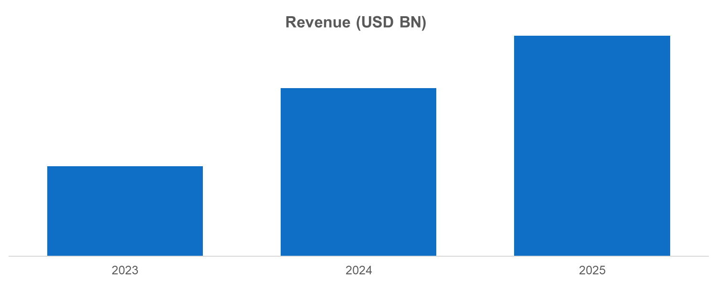
Source: Annual Reports, Primary Interviews, Surveys, Secondary Research, , 2025

    - {{co1_name_upper}} Segmental Revenue (%) (2024)
- {{co1_name_upper}} SEGMENTAL Revenue (%) (2024)

Source: Annual Reports, Primary Interviews, Surveys, Secondary Research, , 2025

    - {{co1_name_upper}} Regional Revenue (%) (2025)
- {{co1_name_upper}} Regional Revenue (%) (2025)
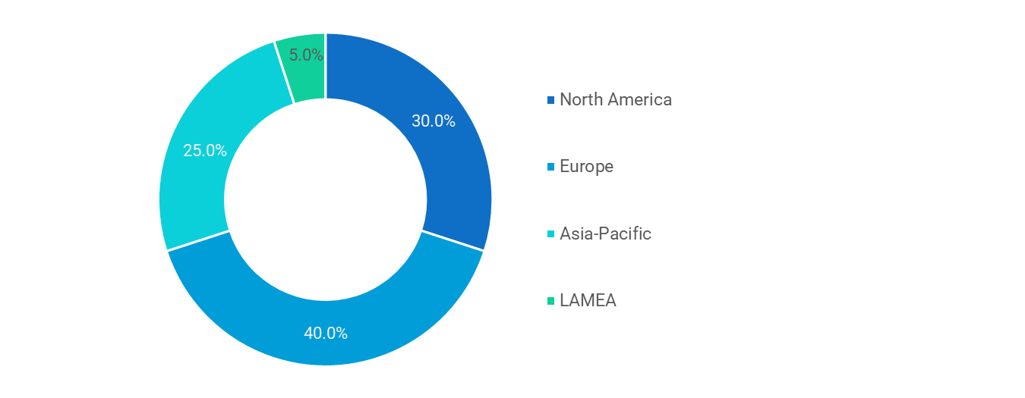
Source: Annual Reports, Primary Interviews, Surveys, Secondary Research, , 2025
Similar infoamtion will be provided for berlow companies
  - {{co2_name}}
  - {{co3_name}}
  - {{co4_name}}
  - {{co5_name}}
  - {{co6_name}}
  - {{co7_name}}
  - {{co8_name}}
  - {{co9_name}}
  - {{co10_name}}
- Future Outlook & Forecast- {{market_name_upper}} Market
  - IntroductionTaxonomy

  - Demand Forecast

  - Investment Opportunity

  - Market Disruptions & Scenario Analysis
- Strategic Recommendations – {{market_name_upper}} Market
  - IntroductionTaxonomy

  - For Manufacturers

  - For Investors

  - For Policy Makers

- Appendix
  - Data Sources

  - Glossary of Terms

  - Research Assumptions

About us
Welcome to NextGen Intelligence StatsConsulting -your trusted partner in market research and consulting.
Founded with a mission to bring clarity to complex markets, we are dedicated to helping businesses make smarter, data-driven decisions. Since our inception, we’ve consistently expanded our offerings, stayed rooted in a client-first approach,remained focused on eliminating unreliable or outdated data from strategic planning.
We are more than just a research firm-we are a one-stop hub for meaningful industry intelligence. Whether you're a startup exploring new markets or an enterprise navigating growth, our team works closely with you to uncover real opportunities, decode market movements,guide you toward sustainable success.
We understand that every client is unique. Syndicated reports can’t always capture the nuances of your business goals — which is why we offer flexible, custom research solutions tailored to your specific objectivesbudget. From targeted market analysis to in-depth consulting, we’re here to provide insights that are both practical and powerful.
At NextGen Intelligence StatsConsulting, we stand for quality, integrity, and partnership. Our commitment is simple: to deliver best-in-class research and consulting services that empower your business to stay ahead of the curve.

Let us help you turn data into direction-and insights into impact.

Copyright © 2025 {{company_name}} All rights reserved

Disclaimer
The informationinsights provided by NextGen Intelligence Stats and Consulting are intended solely for general informational purposes. While we strive to ensure accuracy and reliability in our research and consulting services, we make no representations or warranties, express or implied, regarding the completeness, accuracy, or suitability of the content for any specific purpose. All opinions and analyses are based on available data at the time of publication and are subject to change without notice.
NextGen Intelligence StatsConsulting shall not be held liable for any direct or indirect loss or damage arising from the use of our reports, publications, or services. Clients are advised to exercise their own judgment and seek independent professional advice before making any business or investment decisions based on our research.
Use of our services or content implies acceptance of this disclaimerour terms of service.

